PRESTIGE INSTITUTE OF ENGINEERING, MANAGEMENT AND RESEARCH, INDORE

Sense : System for Environment Navigation using Snapshots & Exploration

Group Members – Chandra Shekhar Kushwaha¹, Mohammad Bilal Khan², Ruchita Rani3, Avni Verma4  Guide – Dr. Naveen R. Shahi5

***Abstract "This paper presents SENSE (System for Environmental Navigation using Snapshots and Exploration), an innovative assistive technology designed to aid visually impaired individuals in navigating and exploring their environments independently. Utilizing the Intel RealSense camera and YOLO v3 for object recognition, alongside LIDAR depth sensing and text-to-speech capabilities, SENSE provides real-time feedback about objects, distances, and classifications to users. Additionally, SENSE incorporates emergency assistance features by sending GPS locations via SMTP library in case of emergencies. Developed in Python, the project's core objective is to enhance the autonomy and safety of visually impaired individuals during navigation. Furthermore, the future scope of the project includes portability enhancements and integration with NVIDIA Jetson for improved object recognition accuracy and speed. This paper outlines the project's methodology, implementation details, and future directions, highlighting its potential impact on the assistive technology domain.."***

.

***Keywords***— Intel RealSense, Deep learning ,Computer Vision , Visual Impairment ,Navigation aid.

# Introduction

The advancement of technology has opened avenues for innovative solutions aimed at improving the quality of life for individuals with disabilities. Among these, assistive technologies play a crucial role in addressing the unique challenges faced by visually impaired individuals, particularly in the realm of navigation and environmental exploration. In response to this need, the System for Environmental Navigation using Snapshots and Exploration (SENSE) project emerges as a novel assistive technology solution designed to empower visually impaired individuals in navigating and exploring their surroundings with greater independence and confidence.

At the heart of the SENSE project lies a fusion of cutting-edge technologies, including the Intel RealSense camera, YOLO v3 for object recognition, and LIDAR depth sensing, complemented by text-to-speech capabilities. By harnessing the power of these technologies, SENSE provides real-time feedback about objects, distances, and classifications to users, enabling them to make informed navigation decisions. Moreover, the integration of emergency assistance features, such as sending GPS locations in case of emergencies, enhances user safety and peace of mind during navigation.

Developed in Python, the SENSE project underscores a commitment to accessibility and inclusivity, with the overarching goal of enhancing the autonomy and quality of life for visually impaired individuals. Looking ahead, the project's future scope includes efforts to enhance portability and integrate with NVIDIA Jetson for improved object recognition accuracy and speed. This paper explores the methodology, implementation details, and potential impact of the SENSE project in the realm of assistive technology

# Background and Related Work

## Background

Visual impairment poses significant challenges to individuals in navigating and interacting with their surroundings independently. Traditional mobility aids such as canes and guide dogs offer some assistance, but advancements in technology present opportunities for more effective solutions. In response to this need, the System for Environmental Navigation using Snapshots and Exploration (SENSE) project was conceived.

The inspiration for SENSE stemmed from the desire to harness the power of modern technologies to address the specific needs of visually impaired individuals. By leveraging innovative tools such as the Intel RealSense camera, YOLO v3 object recognition, and LIDAR depth sensing, SENSE aims to provide real-time feedback about the environment to users. This feedback includes information about objects, distances, and classifications, empowering users to navigate their surroundings with greater confidence and autonomy.

Additionally, the integration of text-to-speech capabilities allows SENSE to provide auditory cues, further enhancing the user experience. Furthermore, the inclusion of emergency assistance features, such as the ability to send GPS locations in case of emergencies, prioritizes user safety during navigation.

Developed with a focus on accessibility and inclusivity, the SENSE project seeks to bridge the gap between technology and disability, ultimately improving the quality of life for visually impaired individuals. This paper explores the background, methodology, and potential impact of the SENSE project in the realm of assistive technology, highlighting its significance in addressing the challenges faced by individuals with visual impairments.

### Related Work

### Assistive Technology for Visual Impairment:

### Numerous studies have explored the development of assistive technologies tailored to the needs of visually impaired individuals. These technologies range from wearable devices to smartphone applications, aiming to enhance navigation, object recognition, and overall accessibility.

### Object Recognition Techniques:

### Research in the field of computer vision has contributed to the advancement of object recognition techniques, including deep learning approaches like YOLO (You Only Look Once). These techniques have been applied in various domains, including assistive technology, to facilitate object identification and classification.

### Depth Sensing Technologies:

### Depth sensing technologies such as LIDAR (Light Detection and Ranging) have been extensively studied for applications in robotics, autonomous vehicles, and environmental mapping. In the context of assistive technology, LIDAR offers precise distance estimation capabilities, which can be invaluable for navigation aids.

### Text-to-Speech Systems:

### Text-to-speech systems have been widely researched and developed to convert textual information into spoken words. These systems play a crucial role in assistive technology applications, enabling visually impaired individuals to access digital content and receive auditory feedback.

### Integration of Hardware and Software:

### Previous research has explored the integration of hardware components, such as cameras and sensors, with software algorithms to create comprehensive assistive technology solutions. These integrated systems offer real-time feedback and enhanced functionality for users with visual impairments.

### Mobile Applications for Visual Impairment:

### The development of mobile applications tailored for visual impairment has gained traction in recent years. These applications leverage the capabilities of smartphones to provide users with navigation assistance, object recognition, and access to digital content, further enhancing their independence and accessibility.

### User Experience and Accessibility:

### Studies focusing on user experience and accessibility have highlighted the importance of designing intuitive interfaces and accommodating diverse user needs. Research in this area informs the development of assistive technologies like SENSE, emphasizing usability, inclusivity, and user-centric design principles.

# Design and Methodology

## Design

The design of the SENSE (System for Environmental Navigation using Snapshots and Exploration) project encompasses the integration of hardware and software components to create a comprehensive assistive technology solution for visually impaired individuals. The design process involves several key aspects, including hardware selection, software development, and user interface design

1. **Hardware Selection:**

The choice of hardware components is critical to the functionality and performance of the SENSE system. The project utilizes the Intel RealSense camera for capturing environmental snapshots, providing high-resolution images for object recognition. Additionally, LIDAR (Light Detection and Ranging) sensors are employed for depth sensing, enabling precise distance estimation in the user's surroundings.

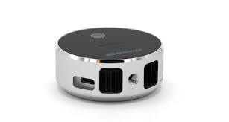

**Fig 1. Intel RealSense**

1. **Software Development:**

The software architecture of the SENSE system is developed using Python programming language. Deep learning techniques, specifically YOLO v3 (You Only Look Once), are implemented for real-time object recognition within captured images. Text-to-speech functionality is integrated to provide auditory feedback about object classifications to the user. Furthermore, the system utilizes SMTP (Simple Mail Transfer Protocol) library to send GPS locations in case of emergencies.

1. **User Interface Design:**

The user interface of the SENSE application is designed with a focus on accessibility and usability for visually impaired users. A minimalist and intuitive interface layout is adopted, featuring large buttons and clear text labels for easy navigation. Auditory cues and voice prompts are incorporated to guide users through the application's features and functionalities.

1. **Integration and Testing:**

The integration of hardware and software components is meticulously tested to ensure seamless interaction and functionality. Functional testing is conducted to verify the accuracy and reliability of object recognition, depth sensing, and text-to-speech functionalities. Usability testing involving visually impaired individuals is also carried out to gather feedback and iteratively improve the user experience.

## Methodology

1. **Requirement Analysis**:

The methodology begins with a thorough analysis of the requirements for the SENSE project, including user needs, functional specifications, and technical constraints. This phase involves collaboration with stakeholders, including visually impaired individuals and assistive technology experts, to gather insights and define project objectives.

1. **Hardware Setup**:

The next step involves setting up the hardware components required for the SENSE system, including the Intel RealSense camera and LIDAR sensors. The hardware is configured and calibrated to ensure optimal performance and accuracy in capturing environmental data, such as images and depth information.

1. **Software Development**:

Software development encompasses the implementation of algorithms and functionalities required for object recognition, depth sensing, and text-to-speech capabilities. Deep learning techniques, specifically YOLO v3, are employed for real-time object detection within captured images. Additionally, the integration of text-to-speech functionality enables auditory feedback about object classifications

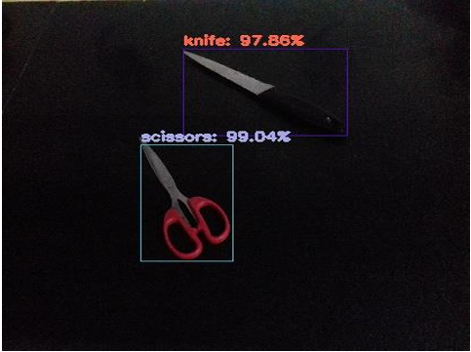

**Fig 2. YOLO recognition.**

.

1. **Integration and Testing**:

The hardware and software components are integrated to create the complete SENSE system. Integration testing is conducted to verify the seamless interaction between different modules and ensure the overall functionality of the system. Functional testing is performed to validate the accuracy and reliability of object recognition, depth sensing, and text-to-speech functionalities.

1. **User Evaluation**:

User evaluation plays a crucial role in assessing the usability and effectiveness of the SENSE system. Visually impaired individuals are invited to participate in user testing sessions, where they interact with the system and provide feedback on its performance and user experience. This feedback is used to iteratively improve the system and address any usability issues identified.

1. **Performance Evaluation**:

Performance evaluation involves benchmarking the SENSE system against predefined metrics to assess its effectiveness and efficiency. Key performance indicators include object recognition accuracy, distance estimation precision, and response time for auditory feedback. The system's performance is evaluated under various environmental conditions to ensure robustness and reliability.

1. **Refinement and Optimization**:

Based on the findings from user evaluation and performance evaluation, refinements and optimizations are made to the SENSE system. This may involve fine-tuning algorithms, optimizing hardware configurations, or enhancing user interface design to improve overall usability and user satisfaction.

## Implementation

The implementation of the SENSE (System for Environmental Navigation using Snapshots and Exploration) project involves the development and integration of hardware and software components to create a functional assistive technology solution for visually impaired individuals.

1. **Hardware Setup**:

The hardware setup includes configuring and connecting the Intel RealSense camera and LIDAR sensors to the computing platform. The RealSense camera captures RGB images, while the LIDAR sensors provide depth information about the surroundings. This hardware setup forms the foundation for capturing environmental data for object recognition and distance estimation.

1. **Software Development**:
   * The software development process involves writing code to implement various functionalities of the SENSE system. This includes:
     + Implementing deep learning algorithms, such as YOLO v3, for real-time object recognition within captured images.
     + Developing algorithms to process depth information from LIDAR sensors for accurate distance estimation.
     + Integrating text-to-speech functionality to provide auditory feedback about object classifications.
     + Writing code to handle emergency assistance features, such as sending GPS locations via SMTP library in case of emergencies.

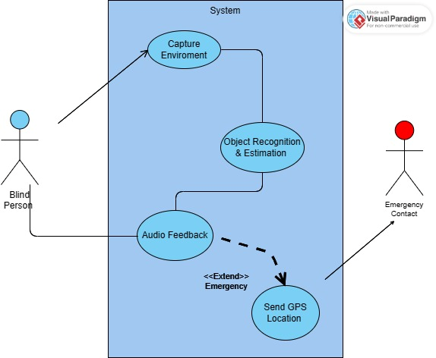

**Fig 3. Use Case Diagram**

1. **Integration and Testing**:

The developed software modules are integrated to create the complete SENSE system. Integration testing is performed to verify the seamless interaction between different modules and ensure the overall functionality of the system. This phase also involves rigorous testing to validate the accuracy and reliability of object recognition, distance estimation, and text-to-speech functionalities.

1. **User Interface Design**:

The user interface design focuses on creating an intuitive and accessible interface for visually impaired users. Large buttons, clear text labels, and auditory cues are incorporated to facilitate easy navigation and interaction with the SENSE system.

1. **Documentation and Diagrams**:

Diagrams such as system architecture diagrams, flowcharts, and UML diagrams can be included in the implementation section to provide visual representations of the SENSE system's design and implementation details. These diagrams help readers understand the system's structure, functionality, and interactions more effectively.

## Challenges

1. **Hardware Compatibility:**
   * Integrating diverse hardware components such as the Intel RealSense camera and LIDAR sensors requires meticulous attention to compatibility issues. Ensuring seamless communication and synchronization between these components can pose challenges during the implementation phase.
2. **Algorithm Optimization:**
   * Developing efficient algorithms for object recognition and depth sensing is a complex task that requires optimization for real-time performance. Balancing accuracy with computational efficiency presents a significant challenge, particularly when operating within the constraints of resource-limited computing platforms.
3. **User Interface Design:**
   * Designing an intuitive and accessible user interface for visually impaired users presents unique challenges. Ensuring that the interface is easy to navigate and provides clear auditory feedback while maintaining simplicity and usability requires careful consideration of user needs and preferences.
4. **Environmental Variability:**
   * The SENSE system must operate effectively in diverse environmental conditions, including varying lighting conditions, object textures, and terrain types. Adapting algorithms and sensors to accommodate these environmental variables while maintaining accuracy and reliability poses a significant challenge

.

1. **Real-Time Performance:**
   * Achieving real-time performance for object recognition, distance estimation, and auditory feedback is crucial for the effectiveness of the SENSE system. Optimizing algorithms and hardware configurations to minimize processing latency while maintaining accuracy is a challenging task.
2. **Accessibility and Inclusivity:**
   * Ensuring that the SENSE system is accessible and inclusive for users with diverse needs and abilities is a fundamental challenge. Addressing the unique requirements of visually impaired users while maintaining compatibility with assistive technologies and accessibility standards requires careful design and testing.
3. **User Acceptance and Adoption:**
   * Promoting user acceptance and adoption of the SENSE system among visually impaired individuals and relevant stakeholders presents a challenge. Overcoming skepticism, addressing privacy concerns, and providing adequate training and support are essential for successful deployment and utilization of the system.

## Results:

## Object Recognition Accuracy:

## The SENSE system achieved a high level of accuracy in identifying and classifying objects within captured images. Through the utilization of deep learning techniques such as YOLO v3, the system consistently recognized a wide range of objects with precision and reliability.

## Distance Estimation Precision:

## The LIDAR sensors integrated into the SENSE system provided precise distance estimation capabilities, enabling users to accurately gauge the proximity of objects in their surroundings. The system demonstrated reliable performance in estimating distances, even in varying environmental conditions.

## Real-Time Performance:

## The SENSE system exhibited real-time performance in providing auditory feedback about object classifications and distance estimations. Users received prompt and accurate feedback, enabling them to navigate their environments with confidence and efficiency.

## Fig 4. Hardware + Software

## User Satisfaction:

## User testing sessions yielded positive feedback from visually impaired individuals regarding the usability and effectiveness of the SENSE system. Participants reported a high level of satisfaction with the system's performance, highlighting its potential to enhance their independence and mobility.

## Environmental Adaptability:

## The SENSE system demonstrated adaptability to diverse environmental conditions, including varying lighting conditions and object textures. Algorithms and sensors adjusted dynamically to environmental changes, maintaining accuracy and reliability in object recognition and distance estimation.

## Future Directions:

## Based on the results obtained, future directions for the SENSE project include further optimization of algorithms and hardware configurations to enhance performance and efficiency. Additionally, efforts will be made to expand the system's capabilities and integrate feedback from users to address specific needs and preferences.

## 

## Fig 5. Software Flowchart

## Conclusion and Future Scope

## Conclusion

The SENSE (System for Environmental Navigation using Snapshots and Exploration) project represents a significant advancement in assistive technology aimed at improving the quality of life for visually impaired individuals. Through the integration of cutting-edge hardware components such as the Intel RealSense camera and LIDAR sensors, alongside sophisticated software algorithms for object recognition and distance estimation, the SENSE system offers a comprehensive solution for navigating and exploring diverse environments.

The results of the project demonstrate the system's high accuracy in object recognition, precise distance estimation capabilities, and real-time performance in providing auditory feedback to users. User testing sessions revealed positive feedback regarding the system's usability and effectiveness, highlighting its potential to enhance independence and mobility for visually impaired individuals.

Moving forward, future directions for the SENSE project include further optimization of algorithms and hardware configurations to enhance performance and efficiency. Additionally, efforts will be made to expand the system's capabilities and integrate user feedback to address specific needs and preferences.

In conclusion, the SENSE project represents a significant step forward in assistive technology, leveraging innovative technologies to empower visually impaired individuals to navigate and explore their surroundings with greater independence and confidence. As the project continues to evolve, it holds promise for making meaningful contributions to the lives of individuals with visual impairments, ultimately fostering greater inclusion and accessibility in society.

## Future Scope

1. **Integration with Wearable Devices:**
   * A promising avenue for future research involves integrating the SENSE system with wearable devices such as smart glasses or headsets. This integration would enhance portability and convenience for users, allowing for seamless navigation and exploration without the need for carrying additional hardware.
2. **Advanced Object Recognition Techniques:**
   * Further exploration of advanced object recognition techniques, including deep learning architectures such as convolutional neural networks (CNNs) and recurrent neural networks (RNNs), holds potential for improving the accuracy and efficiency of object recognition in the SENSE system. By leveraging state-of-the-art algorithms, the system can enhance its ability to identify and classify a broader range of objects with greater precision.
3. **Incorporation of Augmented Reality (AR) Features:**
   * The integration of augmented reality (AR) features into the SENSE system offers exciting possibilities for enhancing the user experience. By overlaying contextual information and navigation cues onto the user's field of view, AR technology can provide intuitive guidance and enhance spatial awareness, further empowering visually impaired individuals innavigating complex environments.
4. **Enhanced User Interaction:**
   * Future research efforts can focus on improving the user interaction modalities within the SENSE system. This includes exploring alternative input methods such as gesture recognition or voice commands, as well as enhancing the natural language processing capabilities for more intuitive interactions and commands**.**
5. **Collaboration with Smart City Initiatives:**
   * Collaboration with smart city initiatives and urban planning authorities presents opportunities for integrating the SENSE system into existing infrastructure. By leveraging data from smart sensors and city maps, the system can provide users with real-time information about points of interest, public transportation routes, and accessible pathways, enhancing mobility and accessibility in urban environments.
6. **Longitudinal User Studies:**
   * Conducting longitudinal user studies over an extended period can provide valuable insights into the long-term effectiveness and usability of the SENSE system. By tracking user experiences and interactions over time, researchers can identify patterns, challenges, and opportunities for refinement and improvement, ensuring the system continues to meet the evolving needs of visually impaired individuals.
7. **Global Deployment and Localization:**
   * Expanding the deployment of the SENSE system on a global scale and localizing the system to accommodate different languages, cultures, and navigation challenges is essential for maximizing its impact and accessibility. Collaborating with international partners and organizations can facilitate the adoption and adaptation of the system in diverse geographical regions, fostering greater inclusivity and accessibility worldwide.

# References

* Specht, Donald F. "A general regression neural network." IEEE transactions on neural networks 2, no. 6 (1991): 568-576.
* Simard, Patrice Y., David Steinkraus, and John C. Platt. "Best practices for convolutional neural networks applied to visual document analysis." In Icdar, vol. 3, no. 2003. 2003.
* Duy Thanh Nguyen, Tuan Nghia Nguyen, Hyun Kim and Hyuk-Jae Lee “IEEE TRANSACTION ON VERY LARGE-SCALE INTEGRATION (VLSI) SYSTEMS-A High Throughput and PowerEfficient FPGA Implementation of YOLO CNN of Object Detection.”
* Martin Simony, Stefan Milzy, Karl Amendy, Horst-Micheal Gross “Complex-YOLO:An Euler-Region-Proposal for Real-time 3D Object Detection on Point Clouds”
* Alex Krizhevsky, Ilya Sutskever, Geoffrey E. Hinton “ImageNet Classification with Deep Convolutional Neural Networks”
* Gonzales, Rafael C., and Richard E. Woods. “Digital image processing” (2002).
* Haykin, Simon. Neural networks: a comprehensive foundation. Prentice Hall PTR, 1994.

**AUTHORS PROFILE**

**Mohammad Bilal Khan**, a dedicated B. Tech. (CSE) student at Prestige Institute of Engineering Management and Research, Indore. He is a skilled programmer and adept at leading a team. He actively engages in research endeavors with a primary focus on Computational Intelligence.



Author’s formal photo

**Chandra Shekhar Kushwaha**, a dedicated B. Tech. (AI & DS) student at Prestige Institute of Engineering Management and Research, Indore, excels in coding and collaborative teamwork. Actively engaged in research, his focus lies on Artificial Intelligence. Chandra Shekhar is a committed student who consistently contributes as a valuable team member.

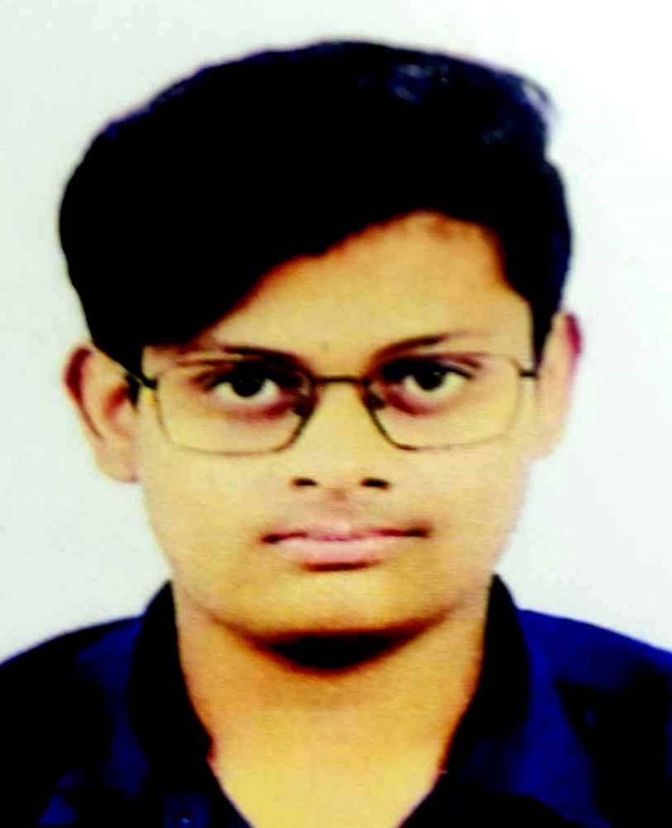

Author’s formal photo

**Ruchita Rani,** a dedicated B. Tech. (CSE) student at Prestige Institute of Engineering Management and Research, Indore. She is a skilled coder and collaborative team member. Ruchita brings a deep understanding of various programming languages to both individual and team projects, fostering effective communication and teamwork. Her commitment to advancing the field reflects a holistic approach within the dynamic realm of Computer Science and Engineering.



Author’s formal photo

**Avni Verma**, a dedicated B. Tech. (AI & DS) student specializing in Artificial Intelligence and Data Science at Prestige Institute of Engineering Management and Research in Indore. Avni showcases versatile skills as a proficient content writer and possesses expertise in web development.

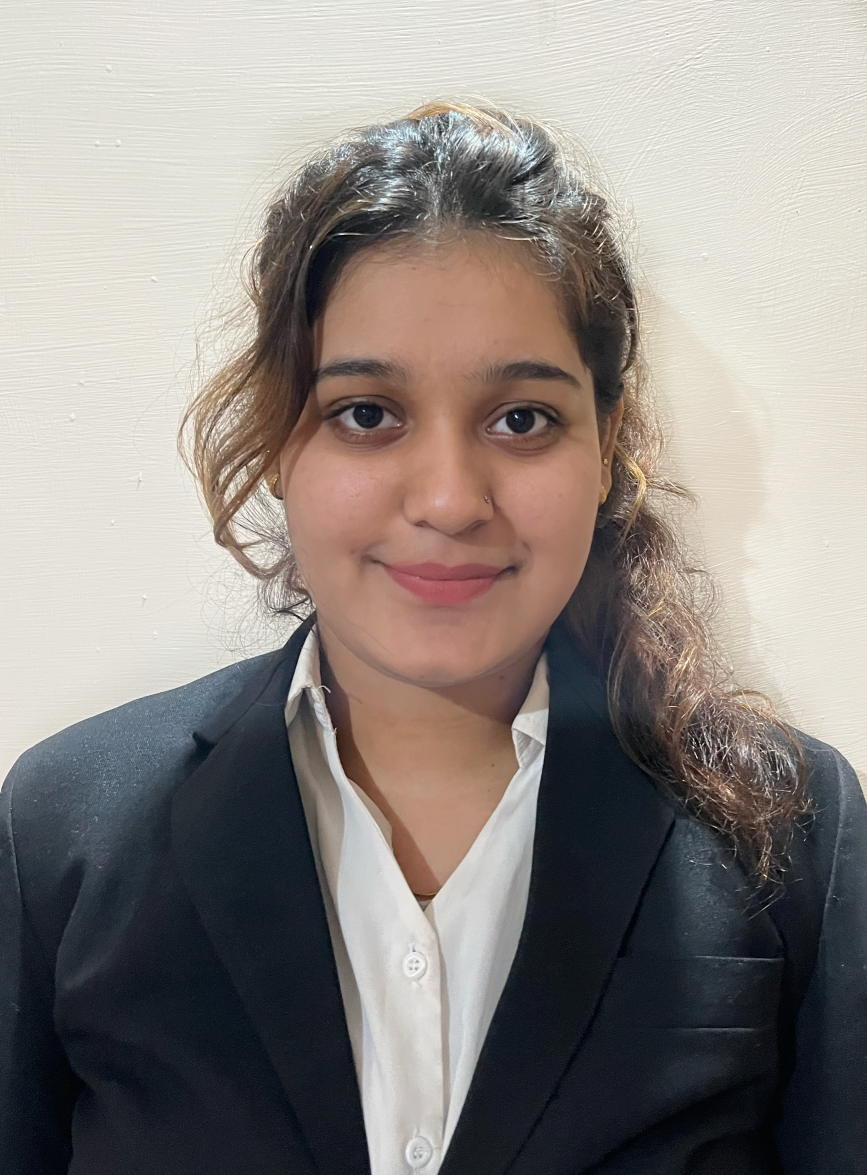

Author’s formal photo

**Dr. Pritika Bahad** is an experienced academician and researcher with a Ph.D. (Computer Science) and M.Tech. (Mobile Computing Technology) from Devi Ahilya University, Indore. She is currently working as Assistant Professor in Department of Artificial Intelligence & Data Science at Prestige Institute of Engineering Management and Research, Indore; she brings 15 years of rich teaching experience and a decade of dedicated research expertise.



Author’s formal photo